/Preview/

**A comparative study between India and Germany by Nazreen and Anjana**

In this project we present a study of Whatsapp, an instant communication channel smartphone application. Through our interviews with participants, we develop anthropologist Tim Ingold’s notion of dwelling, and discuss how use of Whatsapp is constitutive and essentiality of a student life. We investigate student habits and how the features supported by Whatsapp seamlessly integrate into the daily life cycle of students.

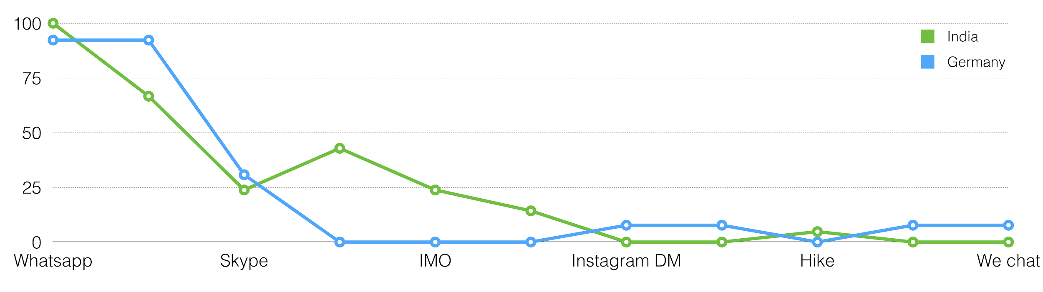

The percentage of OTT(Over The Top) applications in India and Germany

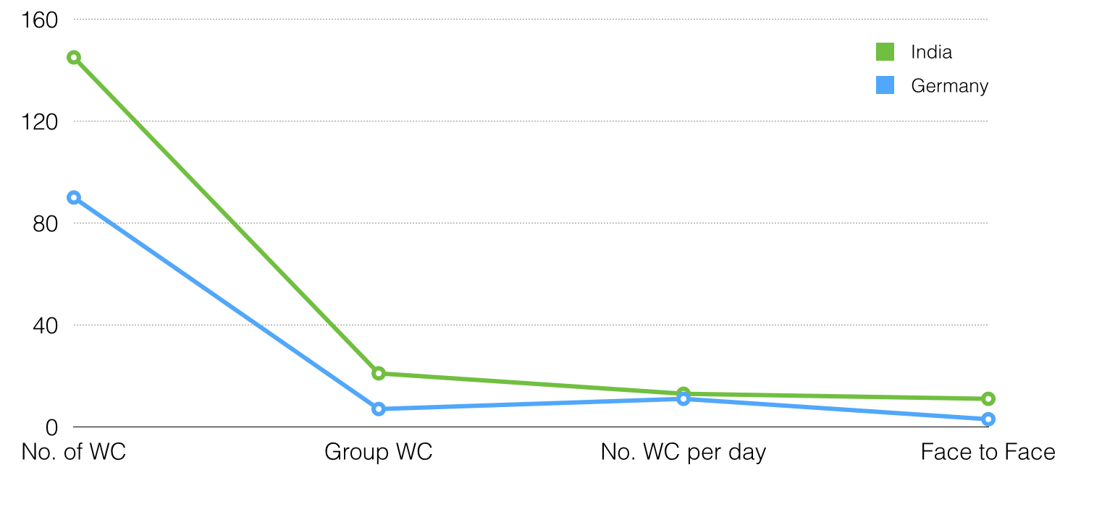

/on click full image/

No. of WC - number of whatsapp chats, Group WC - Group whatsapp chat, No. of WC

per day - number of whatsapp chats per day, Face to face - whatsapp chats with

people met face to face the same day.

The main objective of this paper:

● to evaluate the degree of the impact of the use of Whatsapp Messenger

● to determine the relationship between the use of the application and social bond construction

● to determine how whatsapp helps in the daily life of students in technical institutions of both the countries.

The report can be downloaded from [here](https://drive.google.com/drive/folders/0B372owFok6P-VGVqVzBZQTNCb1U)